A Fitz Style Journal Entry

Use this rubric to help create and post engaging and compelling blog posts!

Set the Scene & State the Theme;
Say What You Mean, & Finish It Clean!
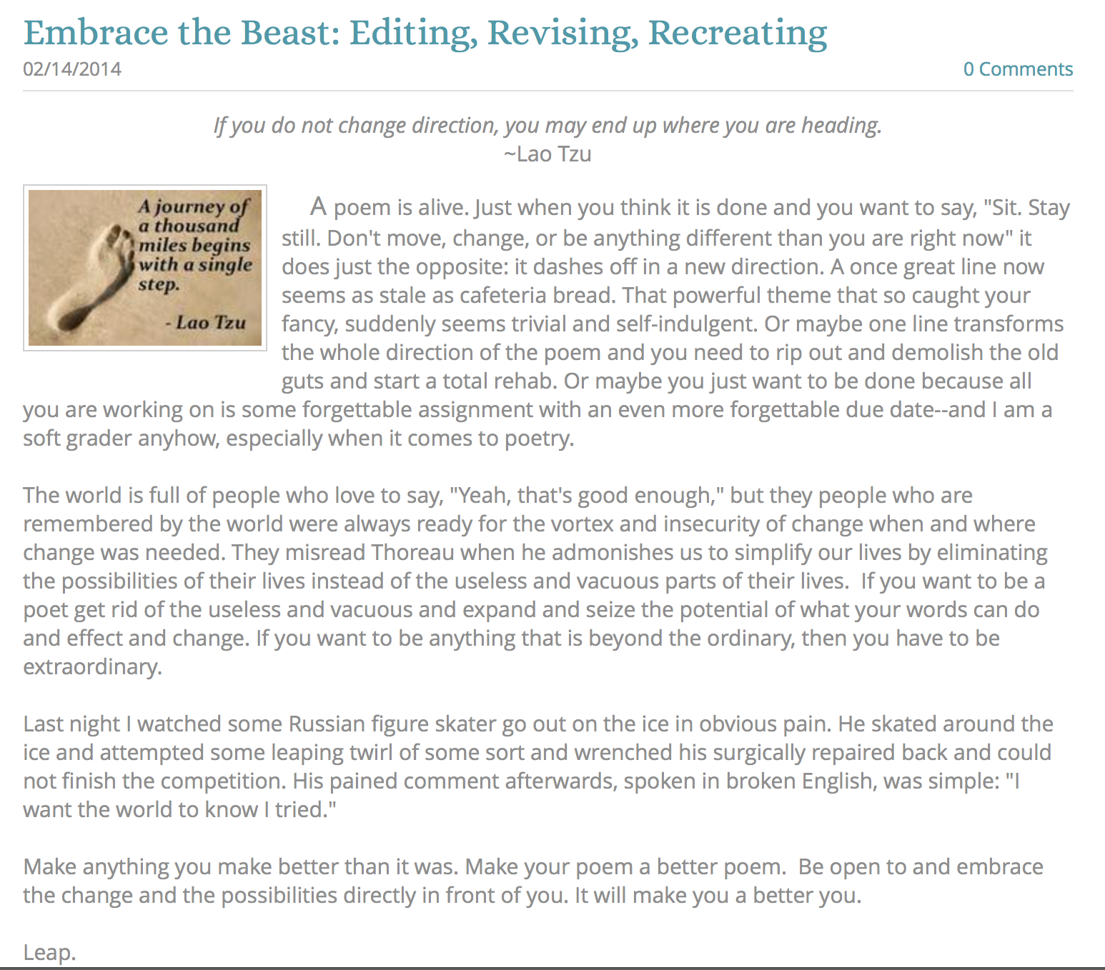

When writing a blog post, is important to remember that a reader is also a viewer. He or she will first “see” what is on the screen, and that first impression will either attract their attention and interest—or it may work to lose their attention and interest; hence, a bit of “your attention” to the details will go a long way towards building and maintaining an audience for your work. Plus, it gives your blog a more refined and professional look and feel—and right now, even as a young teenager, you are no less a writer than any author out there.

So act like a writer. Give a damn about how you create and share your work and people will give a damn about what you create! It is a pretty simple formula.

Below is a rubric for how to create a “Fitz Style” journal entry. I call it “Fitz Style” only because I realized that over time my journal posts began to take on a “form” that works for me. Try it and see if it works for you. You can certainly go above and beyond what this does and add video or a podcast to go along with it—and certainly more images if it is what your post needs. Ultimately, your blog is your portfolio that should reflect the best of who you are and what interests you at this point in your life presented in a way that is compelling, interesting, and worth sharing.

One of the hardest parts of writing is finding a way to make sense of what you want to say, explain, or convey to your readers--especially when facing an empty page with a half an hour to kill and an entry to write (or a timed essay or exam writing prompt). Here is a quick formula that might help you when you need to create a writing piece "on the fly." At the very least, it should guide you as your write in your blog, and at the really very least, it will reinforce that any essay needs to be at least three paragraphs long! I've always told my students (who are probably tired of hearing me recite the same things over and over again): "If you know the rules, you can break them." But you'd better be a pretty solid writer before you start creating your own rules. The bottom line is that nobody really cares about what you write; they care about how your writing affects and transforms them intellectually and emotionally as individuals.

If a reader does not sense early on that your writing piece is worth reading, they won't read it, unless they have to (like your teachers), or they are willing to (because they are your friend). Do them all a favor and follow these guidelines and everyone will be happy and rewarded. Really!

Formatting
How something “looks” is important. Never publish something without “looking” to see the finished product in your portfolio or blog.
Interesting Title  After the initial look, the title is the first thing a reader will see. The title should capture the general theme of your journal entry in an interesting and compelling way. | Embrace the Beast
Relevant Quote  A short and pithy quotes works in tandem with your title to capture the essential theme of your entry. Quotes are easy to find online—or even make one up, or steal one from your writing piece. | If you do not change direction, you may end up where you are heading.  ~Lao Tzu
Eye-catching Image
An image embedded in your post is the final touch of the formatting. A picture really does paint a thousand words and this final touch prepares your readers and entices them to read the important stuff—the actual writing piece you create.
Opening Paragraph | Example Text
The “Hook!”  A hook is just what it says it is—a way to hook your reader’s attention and make him or her eagerly anticipate the next sentence, and really, that is the only true hallmark of a great writer! | A poem is alive.
Set the Scene  Use your first paragraph to lead up to your theme. If the lead in to your essay is dull and uninspired, you will lose your readers before they get to the theme. If you simply state your theme right off the bat, you will only attract the readers who are "already" interested in your topic. Your theme is the main point, idea, thought, or experience you want your writing piece to convey to your audience. (Often it is called a "Thesis Statement.) | Just when you think a poem is done and you want to say, "Sit. Stay still. Don't move, change, or be anything different than you are right now,” it does just the opposite: it dashes off in a new direction. A once great line now seems as stale as cafeteria bread. That powerful theme that so caught your fancy, suddenly seems trivial and self-indulgent. Or maybe one line transforms the whole direction of the poem and you need to rip out and demolish the old guts and start a total rehab. Or maybe you just want to be done because all you are working on is some forgettable assignment with an even more forgettable due date--and I am a soft grader anyhow, especially when it comes to poetry.
State the Theme  I suggest making your theme be the last sentence of your opening paragraph because it makes sense to put it there, and so it will guide your reader in a clear and, hopefully, compelling way. In fact, constantly remind yourself to make your theme be clear, concise and memorable. Consciously or unconsciously, your readers constantly refer back to your theme as mnemonic guide for "why" you are writing your essay in the first place! Every writing piece is a journey of discovery, but do everything you possibly can to make the journey worthwhile from the start. | If you want to be a poet get rid of the useless and vacuous and expand and seize the potential of what your words can do and effect and change. If you want to be anything that is beyond the ordinary, then you have to be extraordinary.
Body Paragraphs | Example Paragraphs
Say What You Mean  Write about your theme. Use as many paragraphs as you "need." A paragraph should be as short as it can be and as long as it has to be. Make the first sentence(s) "be" what the whole paragraph is going to be about.  Try and make those sentences be clear, concise and memorable (just like your theme) and make sure everything relates closely to the theme you so clearly expressed in your first paragraph. If your paragraph does not relate to your theme, it would be like opening up the directions for a fire extinguisher and finding directions for baking chocolate chip cookies instead!  And finally, do your best to balance the size of your body paragraphs. If they are out of proportion to each other, then an astute reader will make the assumption that some of your points are way better than your other points, and so the seed of cynicism will be sown before your reader even begins the journey. | The world is full of people who love to say, "Yeah, that's good enough," but the people who are remembered by the world have always been ready for the vortex and insecurity of change when and where change was needed. They are the ones who misread Thoreau when he admonishes us to simplify our lives by eliminating the possibilities of their lives instead of the useless and vacuous parts of their own lives.
Body Paragraph #2 | Last night I watched some Russian figure skater go out on the ice in obvious pain. He skated around the ice and attempted some leaping twirl of some sort and wrenched his surgically repaired back and could not finish the competition. His pained comment afterwards, spoken in broken English, was simple: "I want the world to know I tried."
Conclusion | Example Conclusion
Finish It Clean  Conclusions should be as simple and refreshing as possible. In conversations only boring or self important people drag out the end of a conversation.  When you are finished saying what you wanted to say, exit confidently and cleanly. DON"T add any new information into the last paragraph; DON'T retell what you've already told, and DON'T preen before the mirror of your brilliance. Just "get out of Dodge" in an interesting and thoughtful (and quick) way.  Use three sentences or less. It shows your audience that you appreciate their intelligence and literacy by not repeating what you have already presented! | All you can ever do is try. It is our greatest strength! Make anything you make better than it was. Make your poem a better poem. Be open to and embrace the change and the possibilities directly in front of you. It will make you a better you.  Leap.

Cut and paste your finished piece in the box below. Proofread, edit, and revise as needed.
Title

Quote

Lorem ipsum dolor sit amet, consectetur adipiscing elit. Nunc nec libero vehicula, malesuada quam vel, commodo lacus. Duis placerat orci quis felis rutrum, quis viverra elit auctor. Integer purus lorem, condimentum vitae vestibulum quis, tincidunt vel mi. Fusce lorem ligula, luctus eget justo eu, luctus suscipit turpis. Proin imperdiet lacus nibh, sit amet cursus quam tincidunt sed. Praesent consequat leo id velit aliquet, pellentesque lacinia ante suscipit. Mauris vehicula urna lorem, at cursus mauris laoreet ac. Curabitur feugiat ex massa, quis sodales lorem varius eu. Nullam non tempor augue. Sed fringilla odio ante. Morbi vel cursus mauris. Sed tristique tincidunt metus sed dignissim. Nam vel risus lorem.

Cras volutpat facilisis urna, nec mattis lorem luctus ac. Donec facilisis id justo et finibus. Vivamus laoreet erat ornare urna tristique varius. Quisque semper neque in ex venenatis, a blandit nunc tincidunt. Pellentesque luctus eget urna eu accumsan. Etiam fringilla porttitor nulla, eu sagittis tellus condimentum tempor. Morbi feugiat nisi ac dui tincidunt, non egestas orci viverra. Nam dapibus dapibus lorem, vel aliquam enim vestibulum eu. Sed sit amet neque placerat, hendrerit eros et, ornare lorem. Vestibulum sollicitudin tortor purus, eget pretium tellus posuere ac. Phasellus ante risus, sagittis at augue vitae, hendrerit hendrerit libero. Cum sociis natoque penatibus et magnis dis parturient montes, nascetur ridiculus mus.

Proin mattis lacus faucibus, volutpat felis vel, consectetur tortor. Donec dictum at nisi nec aliquet. Ut laoreet gravida ex et eleifend. Aliquam convallis auctor urna, a pretium quam vehicula vitae. Donec lacus elit, pellentesque sed ante vel, sodales rhoncus ante. In maximus viverra sem at porta. Nunc ornare pulvinar ullamcorper. Phasellus semper, velit vitae cursus aliquam, quam dolor porttitor leo, id tincidunt tortor metus ac turpis. Vivamus ac justo sit amet mi mollis dapibus. Nam quis pellentesque nulla. Sed cursus augue ut sem scelerisque convallis. Maecenas sollicitudin lorem eu sapien laoreet, eget malesuada magna venenatis.

Etiam quis efficitur erat, et tempor sapien. Cras elit arcu, fringilla eget pretium eleifend, bibendum quis odio. Curabitur est nisl, posuere eget metus nec, blandit hendrerit sapien. Maecenas tincidunt congue sodales.

