The Literary Analysis Paragraph Rubric

Explicating Themes and Their Roles in Literature

“A mighty book requires a mighty theme.”
~Herman Melville

Literary analysis is a type of writing where a writer literally breaks a story down to its most basic elements and then analyzes how and why those elements work in that particular story. These elements include identifying important themes, comparing and contrasting stories and authors, defining writing techniques and devices—and anything else that relates to the way in which a story is structured and told. Literary analysis deals only in what can be proved objectively via the text, and not because how and why a certain story makes you—as an individual—think and feel subjectively about that story. The Literary Analysis Paragraph #1 is designed to help any writer find and explicate the major themes in a story and to define the importance of these themes in the story.

The fact that you, as the analyst, are dealing with objective and provable facts is the main reason why most teachers forbid the use of the “I” voice in this type of writing. It is here where I make the distinction between literary analysis and literary reflection: a literary reflection “reflects” your unique emotional and intellectual response to the story; whereas, a literary analysis “analyzes” the form, devices, style, and content of a story. In an analysis, the “I” is not needed and does not help you prove your point because the point is proved using verifiable facts. Throwing yourself into the mix just muddies the water and burdens your writing with unnecessary words and distractions.

The basic structure of the literary analysis paragraph rubric is, however, essentially the same as the narrative paragraph rubric: you open with a clear and concise guiding theme or topic [broad theme, narrow theme, one/two punch]; you offer supporting facts and proof [smoking gun]; and in your third section of the paragraph, you explain and explicate how your guiding theme relates to the story [head and heart]. Finally, you “get on or get out.” If you are writing a single paragraph, you get out with a sense of finality; if you are writing a multi-paragraph essay, you may need to find a way to transition in a logical and unforced way to the next paragraph in your essay.

It is important as a reader, and even more so as a writer, to be able to understand the importance of themes in a piece of literature, for exploring the themes of being human—and being connected (or disconnected) to the rest of humanity is the essential role of any writer! We don’t read because we care about a writer; and if you are a writer, you need to understand that nobody cares about “you” as a person any more than some guy living three towns over from you; however, we do care about ourselves, and if as a writer you put us in touch with a deeper side of our head and heart; if you pull on the strings of our imagination in such a way that we cry when you want us to cry, laugh when you want us to laugh, and think what you want us to think—then you have succeeded as a writer, and those people who do not care about you as a person will care about what you write, and they will beat a path to an door where they can find the pages that hold your words.

Literary Analysis Paragraph Rubric #1

Ten Steps to writing an awesome
Literary Analysis Paragraph

The golden rule of writers is to always know what your readers want and expect—and give it to them in well-crafted writing, which almost always means well-constructed paragraphs! I love using the term “well-crafted” because it implies that writing well requires a deliberate and attentive focus. Good writing is never finished; it is abandoned. Honestly: give yourself ninety minutes to two hours to finish this. A writer’s first words are seldom his or her best words. Over the years I have read and graded thousands of these paragraphs. It is not hard to figure out who gave a damn and who didn’t. It is obvious who reads the details of this rubric before creating his or her own paragraph.

So do your best. Give a damn. It works.

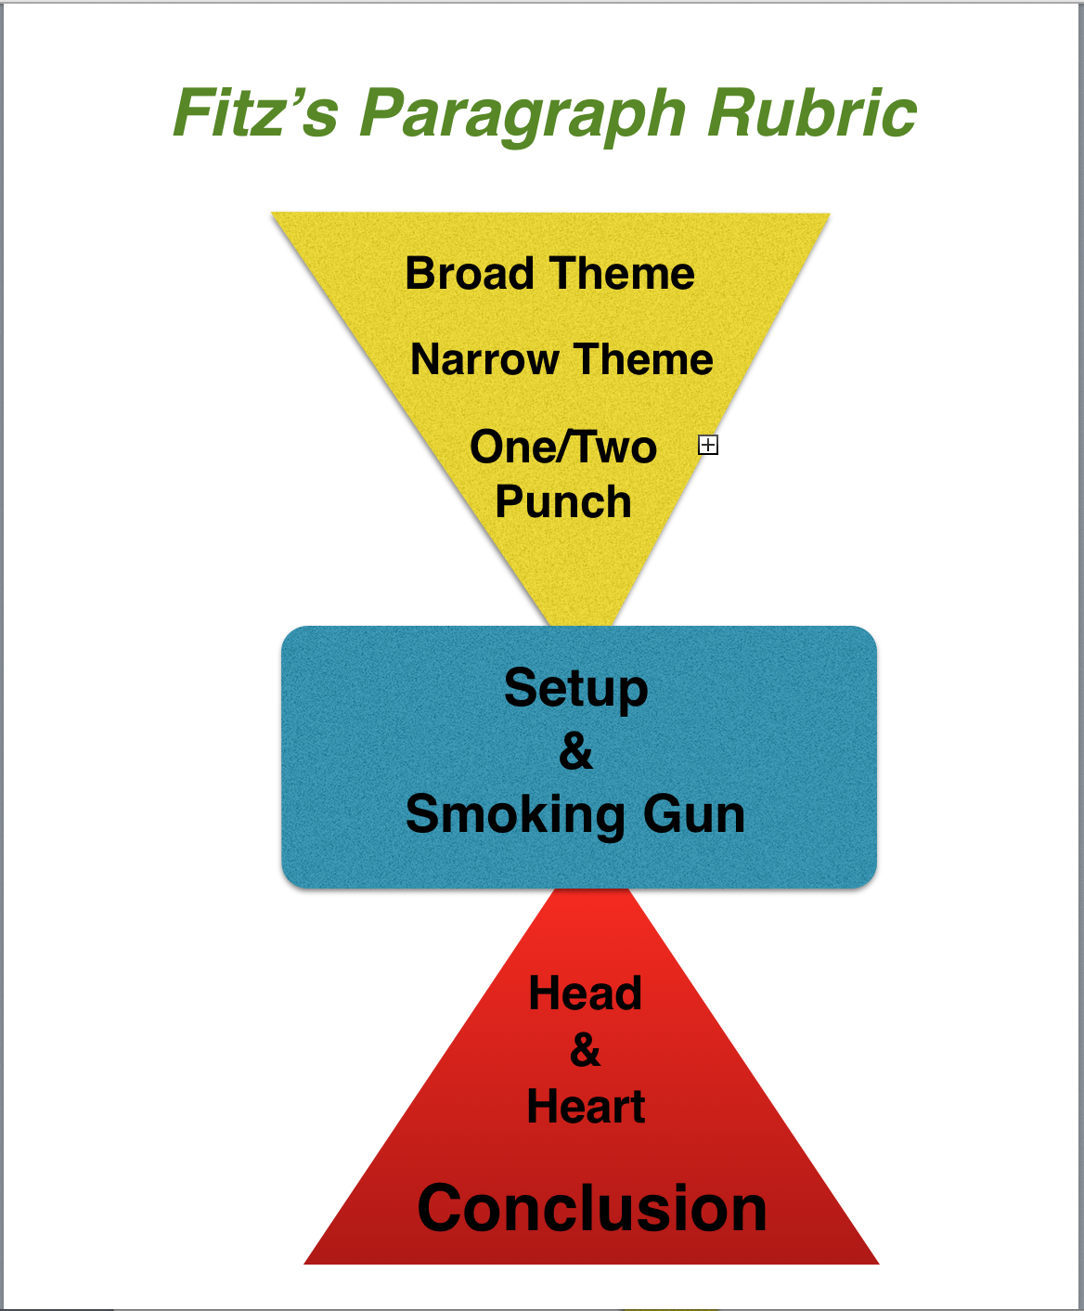
The image below is a visual to help you see
what a detailed paragraph includes:

- The first triangle of the paragraph introduces the theme in a broad way, and then narrows it down to a more focused theme that you can effectively write about in a single paragraph.
- The blue rectangle is the central part of your paragraph. It contains the text reference and text support that “proves” your theme is evident in the actual text.
- The bottom triangle contains the head and heart, which, in many ways, should be the most interesting and thoughtful part of your paragraph. It is where you discuss the importance of the theme in the text support and text reference in the smoking gun. See how (as opposed to the upper triangle) it starts narrow and expands to allow you to logically tie back in to your broad theme in your concluding sentence.

Be sure to follow “all” of the details of the rubric explained in the steps below, and try your hand at a creating a well-crafted literary analysis paragraph—one that we call a “whamdammer” in my class!

In the rubric below, I use an example paragraph written by Ryan Ewing one of my 8th grade students in 2013. The strength of Ryan’s paragraph is not just that it is a good paragraph; it s because he follows the details of the rubric throughout his paragraph. If you wish, replace his text with your own text, then cut and paste your words into a new document and save and submit as required by your teacher.

1. ASSIGNMENT INFORMATION

  - As Mae West said, “It is better to look marvelous than to feel marvelous.”
  - In that spirit, create assignments that “look” good.
  - In the top right corner of your assignment post your name, class, section, assignment name and date.

Name
Class Section
Assignment Name
Due Date

2. THEME

A paragraph needs to have a unifying theme that is developed and explained throughout the paragraph. In this rubric, we are only writing about a single important theme that can be captured n a single word or short phrase.
- Your one word or short phrase theme is the specific aspect of the human condition that is a central theme in the writing piece. It should be centered below your quote and above your opening paragraph in size 18, bold font.
- Your theme should be one word (ideally) or a short phrase—not a full sentence.

[Put your theme here]

3. MEANINGFUL QUOTE

This quote is by no means “necessary” for a good paragraph, and you would not include it in an essay, but it is a good practice when writing a paragraph, and helps to keep you focused on the theme of your paragraph.
- Choose a quote from the writing piece” that fully captures the theme you wish to explore in your paragraph.
- This quote is the main source for your text reference and text support in your paragraph.
- This can be longer or shorter than you will need or use in your paragraph.
- Center your quote above your paragraph in italics (No quotation marks.) Be sure to cite your source using brackets: For example, [The Odyssey, Book VII, Lines 331-335]

[Put your quote here]

4. BROAD THEME

This is your first sentence of a body paragraph. In a way, it is almost like the “title” of your paragraph. It is meant to indicate the direction of the paragraph in a compelling and interesting way by creating a clear, concise, and memorable statement of a universal theme—which is, hopefully, interesting and compelling to your potential readers.

- Do not mention the writing piece in this sentence because this sentence is supposed to introduce the theme of your paragraph in a general way that is interesting to a potential reader.
- Oftentimes, especially in a longer, multi-paragraph essay, it makes sense to remove this broad theme, but in a one-paragraph response, I’d leave it in there.

[Put your text here]

5. NARROW THEME

This is essentially the topic sentence of your paragraph—and as such, it is the most important sentence in your paragraph! The Narrow Theme narrows down your theme in a specific way by writing a phrase or sentence that captures how your one-word theme is used in the literature you are analyzing. This is your "clear, concise and memorable" topic sentence.

- Be sure to include a specific reference to the writing piece AND a specific reference to your one word theme in this sentence.
- The narrow theme is the sentence that "steers" your reader in the direction you want him or her to go, and it acts as a reminder to your readers why "exactly" you are writing this paragraph.

[Put your text here]

6. ONE/TWO PUNCH

- Follow your Narrow Theme with one or two more sentences (the one/two punch that add detail or explanation to your topic sentence and narrows down the topic even further.
- Beware of creating a series of new topic sentences in your one/two punch.
- At the end of your one/two punch, your readers should have a clear and extremely focused idea of the direction of your paragraph.

[Put your text here]

7. SET UP

The setup is the text “reference” that describes in detail (and explicates) the “scene” leading in to your quote (the smoking gun) from the literary piece. The setup and the smoking gun work together to add the “proof” that you have read and studied the piece of literature you are analyzing. Without the smoking gun, you are just rambling around and going nowhere—unless your readers are already fully aware of everything that happens in your piece of literature.

- The setup to your smoking gun should include a who, what , when, where, why reference to a scene from the piece of literature you are analyzing.
- Use specific images and actions to describe the scene leading into the quote (smoking gun!)
- Notice the colon Ryan uses to “introduce” the quote.
- Notice, too, that he describes this scene in the present tense!

[Put your text here]

8. SMOKING GUN

The smoking gun is the quote (text support) you use from the writing piece you are analyzing. A literary analysis without text support
- Text reference (setup) and text support (smoking gun) work together to prove you've read and analyzed the text and prepares your reader for your head and heart section of the paragraph.
- NOTE: Always include the quote reference after your quote in brackets or parentheses. For example: [The Odyssey, Book One, Lines 234-237]
- It is not always necessary to include the title if it is obvious what literary piece you are writing about.
- “If” your quote is less than two lines as it appears in the final text, put quotation marks at the beginning and end of the quote. Put the quote itself in italics. [This is a personal preference of mine and not a universal “rule” because I feel it helps to identify your text support more clearly and cues the reader more effectively that you are utilizing a quote.]
- If the quote is three lines or more, put the quote in italics without quotation marks; put your quote reference under the quote; create a new paragraph for the quote, and finally, indent the whole quote.
- Remember not to indent the first line of the head and heart that comes after the quote because it is still a part of a single paragraph.

[Put your text here]

9. HEAD & HEART

This is the “brains & brilliance” part of your paragraph. It shows your reader your how much you know and how insightful you are about your theme and how it used in the literary work you are discussing

- Write at least four sentences that, explicate, illustrate, and elaborate upon your topic sentence and the “Theme” as it used in literary piece.
- This is where your passion and knowledge come into play. If you don't have much head and heart, then I immediately sense a lazy or ill-prepared student—or even worse….
- Notice that Ryan includes several references to friendship (his theme) in his head and heart—which is especially important in the final sentence leading into his conclusion.
- Many writers, in their quest to sound smart and informed, fall into the trap of introducing new and/or irrelevant topics into a paragraph—usually at this point, or they add in more text support. Don't!!! It distracts and ticks off good readers, and it confuses and frustrates weak readers. Either way, you lose your audience, which is not a good way to earn a living as a writer.
- If you have a new topic that you feel is awesome, then have the decency to give that topic its own paragraph.

[Put your text here]

10. GET ON OR GET OUT

This is the concluding sentence or sentences that close out your thoughts (get out) or "transition" to a potential new paragraph (get on). Try to make your conclusion as clear, concise and memorable as your opening sentence.
- If this paragraph is "transitioning" to a new paragraph, (as is usually the case in an essay) craft your words in a way that sets up the next paragraph. This creates what is called "logical flow."
- If the paragraph is simply ending, (as in a brief literature response) try and find a way of tying back into your opening theme in a new and refreshing way. This gives your readers a concise and confident visual and mental cue that you have said all you need to say.
- Be sure—one more time—to include a reference to your theme in the conclusion.

10. Copy and Paste Completed Paragraph Here:

In sit amet nulla semper, sodales eros vel, porta dolor. Aenean tincidunt accumsan tortor ut scelerisque. Nunc interdum risus eu magna consequat, eu elementum nisl commodo. Curabitur ut ullamcorper mi. Pellentesque quis suscipit metus, vel lobortis nunc. Duis semper neque et libero fringilla, euismod tempor lacus dignissim. Morbi nec dui ipsum. Nulla quis pellentesque erat. Lorem ipsum dolor sit amet, consectetur adipiscing elit. Mauris eget ex diam. Phasellus eu justo eu tortor convallis lobortis.Duis non dignissim sem. Etiam accumsan gravida fringilla. Morbi lacinia malesuada posuere. Vivamus posuere tortor risus, ut placerat orci interdum commodo. Aliquam nec molestie quam, pharetra luctus orci. Nullam non finibus turpis, quis euismod quam. Vestibulum ante ipsum primis in faucibus orci luctus et ultrices posuere cubilia Curae; Cras vehicula augue quis lectus lacinia, sit amet fermentum massa condimentum. Praesent pulvinar est lacus, sit amet mattis sem pretium eu. Sed nec bibendum erat. Curabitur vitae lorem felis. Nullam mauris nibh, consectetur a tortor non, interdum porta nunc. Quisque elit justo, volutpat ut hendrerit vel, mattis in mauris. Etiam risus quam, volutpat eu augue sed, posuere pellentesque lectus.

THE POTSAID RULE OF THREE
Proofread, Edit, Revise, & Submit
- Literature is abandoned, not finished! Go back and re-read what you have written.
- Find three areas or sentences that you can make better. If you can't or won't do this, then you are light years away from being a writer.
- Often you can find a better broad or narrow theme sentence somewhere else in the paragraph. You can almost always find a more clear and effective way to write a sentence than you wrote on your first try.
- If the rule of three was too easy (meaning you easily found mistakes) do it again...and again if you have to.

*When you are convinced you have done all you can, submit your final review as required by your teacher or editor.
©Created by John Fitzsimmons
TheCraftedWord.org

